Exponential Functions:

- Definition

2. Graphs

Note: In the long run, exponential growth faster than any polynomial/power functions
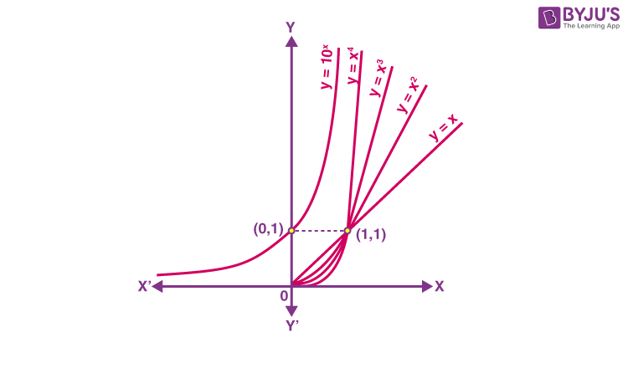
Paper folding Example
Fold a sheet of paper a few times. How thick the folded paper would be?

Everytime we fold, the thickness of the paper double.

How thick the paper would be after folding it 42 times? (assume that the paper is large enough to fold)

It would be thick enough that I could reach the moon. Thicker than the distance from the earth to the moon.
Let’s prove it.

We need to know how thick is a sheet of paper.

A regular sheet of paper is 0.004 inches

Since the thickness of the paper is doubled every time we fold, the thickness of the paper after being fold x times is:

After folding 42 times (x =42), the thickness is

= 17592186044.4 (inches)
= 277,654 (miles)
The distance from the earth to the moon is: 238,900 (miles)
This means that the paper after being folded 42 times is thicker than the distance between earth and the moon.
- Two forms: base e and base b

4. Solving Exponential Equations.

Log operator/function

Logarithm properties

How to solve exponential equations using log:

Solving steps:
- Isolate the base
- Take the log of both sides
- Use logarithmic properties to simplify the expression and solve for x
- Round all answers to 4 decimal places
Example:

Solve:

